Lambda integrated with s3 bucket

1. First we need to create s3 bucket in console
2. After that we have to create lambda function and event.
3. Write a code in lambda function to get the objects in s3 bucket.

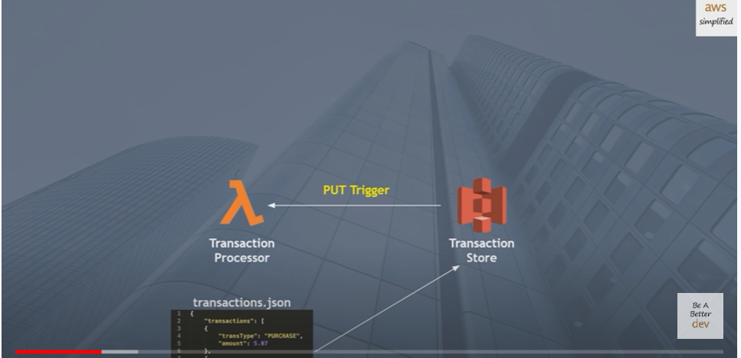

Creating lambda function

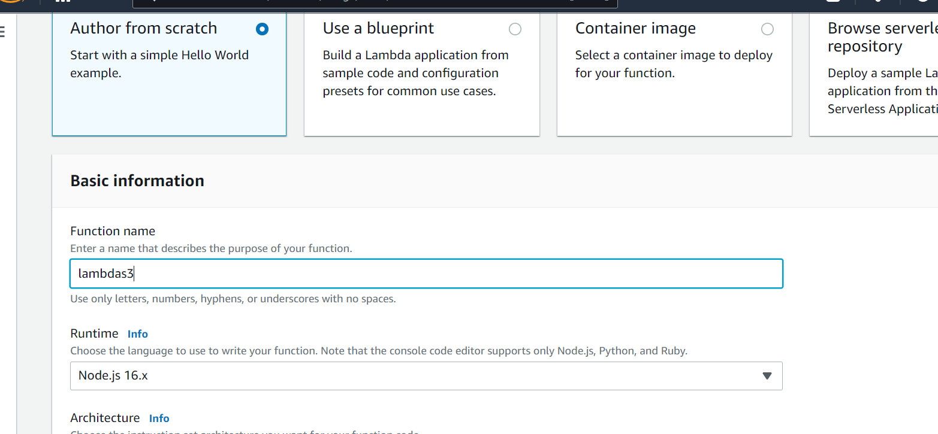

Here we have to provide runtime details and role details.

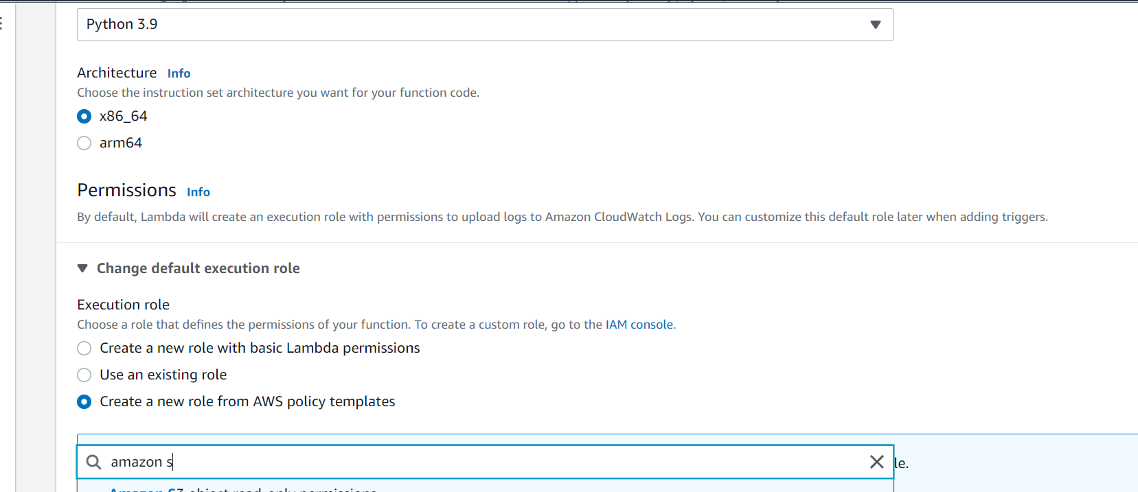

Function has been created successfully

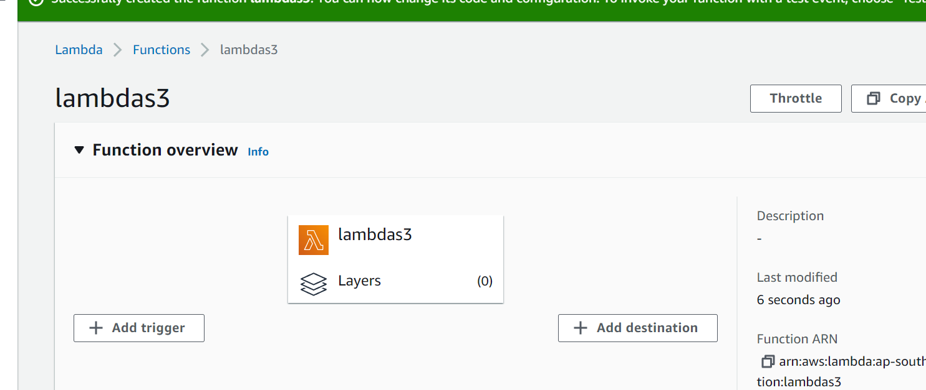

Write the function code like below to get the s3 objects.

